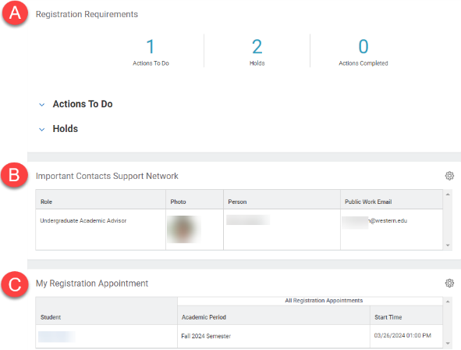
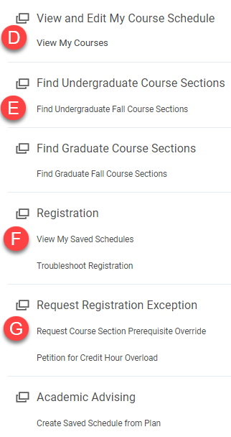
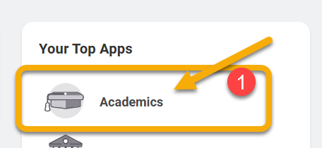
- Registration Requirements: This window displays required Actions to Do and Holds on your account.
INSTRUCTIONS
- To access your Academic app, log into Workday and click Academics.
- Scroll down to view all the options in the Academics app. See the highlights below,
TIP: When navigating in Workday, right click links to open pages in a new tab.

From your Academic App, you can register for courses, add or drop courses, view your schedule, and more.
- Important Contacts Support Network: This window displays the name and contact information of your academic advisor.

- My Registration Appointment: You are able to register for classes during your registration appointment. Your appointment window begins at the date and time displayed in the Start Time column.

- View My Courses: Follow this link to see your current registration information.

- Find Undergraduate/Graduate Course Sections: Follow this link to search for up-to-date course information.

- View My Saved Schedules: Follow this link to review and edit your saved schedules.

- Request Registration Exception: Follow the links under this heading to request a prerequisite override or to petition for credit hour overload.

